Task 2

Task scheduler:

Windows specifications:

Edition: Windows 10 Home

Version: 1809

To schedule a batch file on windows 10, you’ll need to follow certain steps:

1. Open **start.**
2. Search for **Task Scheduler** and open it.
3. To the left corner, right click on the **Task Scheduler Library** and select **New Folder**. In the pop up window, enter the name of the folder and click on **OK**.

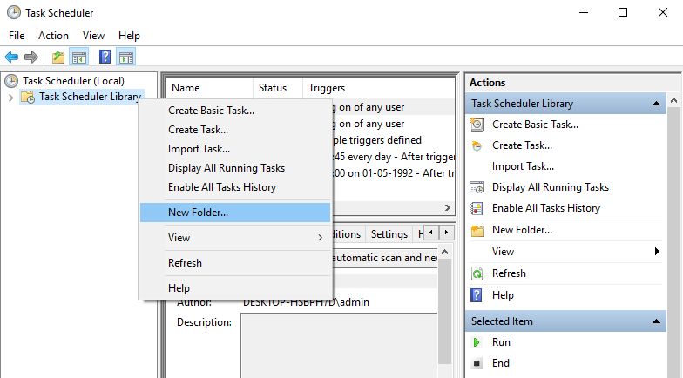

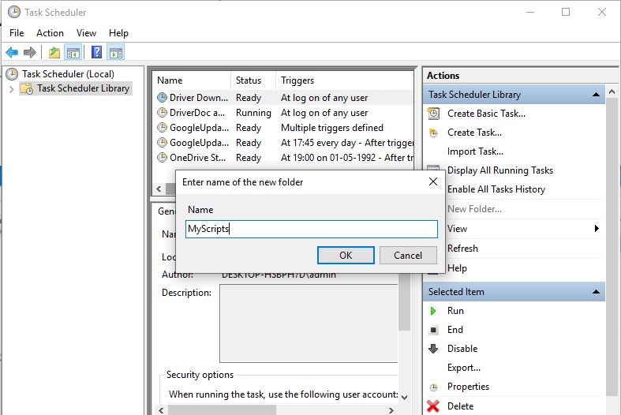

1. Expand the **“Task Scheduler Library”** branch and give a right click on your folder **“MyScripts”.**
2. Choose the option **“Create Basic Task”.**

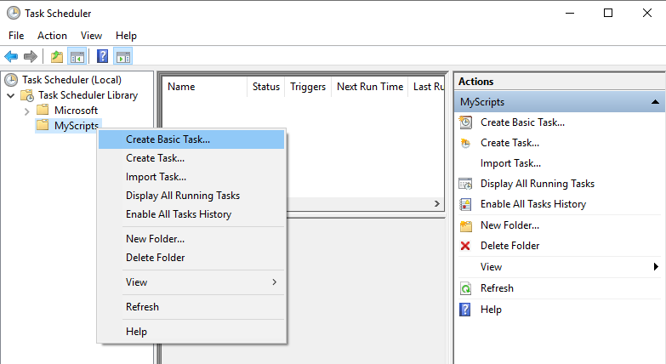

1. In the name field that is available, give the name of the task for example, expand_string_program.

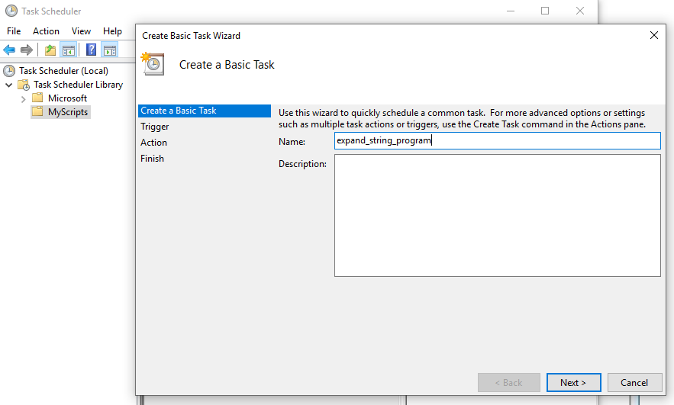

1. The below description field is optional.
2. Click on the **Next** button.
3. Choose any of the options available, depending on when you want your task to start.

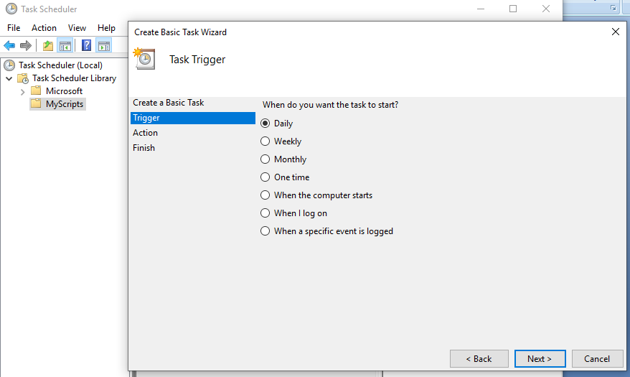

1. Click on **Next** button
2. To specify the time, when to start a task.

Months also can be chosen

Days also can be selected based on the requirement

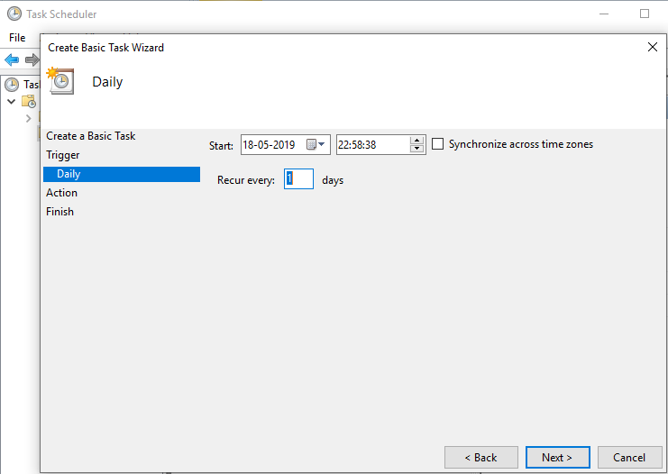

1. Click on **Next** button
2. Select the **Start a program** option to run a batch file.

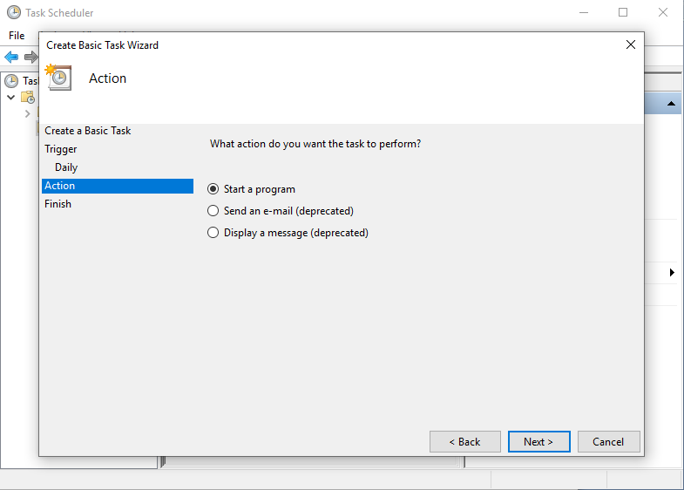

1. In the **Program/script** field, specify the path for the batch file.

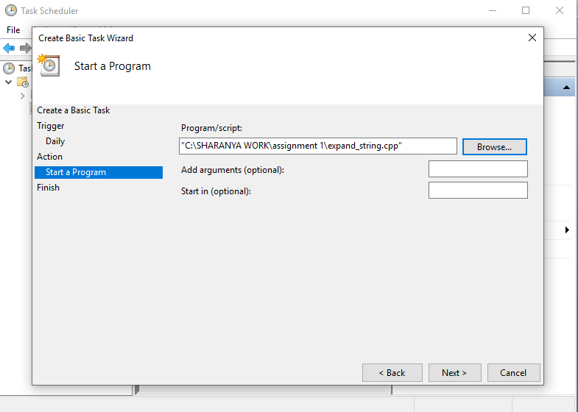

1. Click the **finish** button.

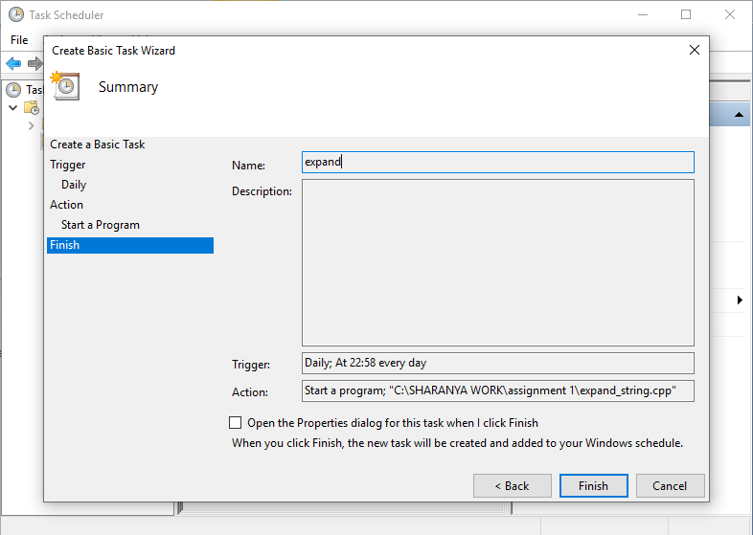

To the time and date that has been set, your selected task will run without any error.